**B2B Website development**

**Aim:** A retail product selling web application.

B2B e-commerce, short for**business-to-business electronic commerce**, is the sale of goods or services between businesses via an online sales portal. In general, it is used to improve the efficiency and effectiveness of a company's sales efforts.

The Potential customers are: Educational institutions, Businesses, etc.

Main business: Online library.

**Blueprint design:-**

URL: <https://quickbooks.co.in>

Header: (will customize the name accordingly)

   (Use hover or focus)





Why only this? (Mention features)

* Effortless searching –

The search box makes it easy for the user to search the required results easier and faster.

* Easy password recovery -

If customer lost his password, he can recover it by selecting forgot password option and system will send his password to his email id.

To make the page more effective, we may also use data tiles or clickable tiles.

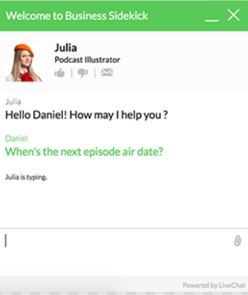 (a customized chatbot)

Visible footer:

Addresses

Contact

E-mail

© All rights reserved 2021

SIGNIN:

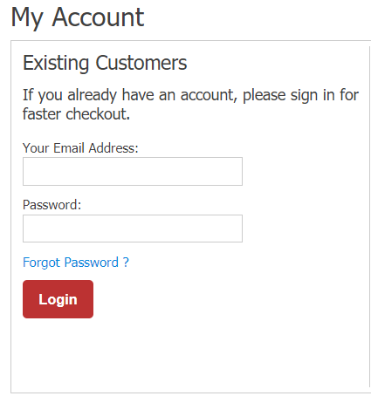

SIGNUP:

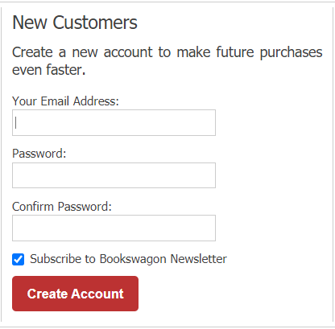

Here’s a link to the theme I prefer it contains only novels but my online library has only bulk orders from my potential customers, so it would have a professional look –

<https://demo3.leotheme.com/prestashop/leo_bookery_demo/en/home-01.html>

TOOLS:

For HTML and CSS, Notepad++.

For JavaScript, Online compiler.

The above blueprint works majorly for the frontend developers, this is an idea can customize it accordingly.